Response to…

*Web Work – A History Of Internet Art*

Rachel Greene

&

The New World of Net Art

*Carolina A. Miranda*

Charly Yan Miller

*Whatever images of net.art projects grace these pages, beware that, seen out of their native HTML, out of their networked, social habitats, they are net.art equivalents of animals in zoos. (Rachel Greene)*

I have been conditioned when offered urls in art related articles to expect some sort of documentation, memorial or post mortem of a performance, installation, canvas… which hoplessly attempts to recreate the experience of a work ex situ. For this reason, one can imagine how strange and exciting it was for me to read an introduction to an article explaining that the urls it offered and the sites they represented were the original medium and context of the art (medium/movement/discourse) which it would be chronicling.

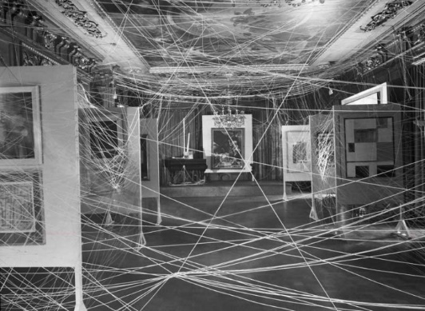Visiting the various websites linked to in Rachel Greene’s article was creatively inspiring and made me realize just how small and rigid my understanding of what a webpage can be and look like are. I found particularly inspiring *JODI.org* largely because of how overtly hostile many of the web pages were: flashing images, dense seas of alphanumeric characters, lists of ip addresses, pages which implored you enter a password and then reportedly *XSSPOSED* you or an endless amount of other absurdly unintuitive or ineligible user interfaces. It reminded me of an idea which was introduced to me (I think) in *The White Cube* when Bryan O’Doherty explains how the modern gallery space (the white cube) has pretensions of elevating art contained within it to a godlike status as it tries to removes all historical, social and political context from the work — granting all objects within the space an ahistorical, universal condition. Simultaneously, the white cube encourages a disembodied experience where persons are transformed into spectators — objective observers of these elevated objects uninhibited by physicality. Works which involve the creation of hostile spaces, for instance: Duchamp’s *First Papers of Surrealism*, subvert these modern pretensions of the white cube by forcedly reminding viewers of their presence within and in relation to the gallery space and art. Jodi.org’s work has a similar affect of making the typical web surfer suddenly and uniquely aware of the underlining architectures, authors, and interfaces of the net – thus dragging the net back into the social, political and technical context of reality.

Lastly *Carolina’s* article focuses a lot on the commercial and economic struggles of net.artists trying to market themselves and make money as much of their work is by the very nature its medium available to all with network access. I wonder if that means that art scenes which do not rely on private buyers but instead government funding like here in Canada would tend to promote the production and proliferation of net.art and net.artists?